**Computer Networks**

**Problem-solving session 7**

**Examine the ARP Table in Cisco Packet Tracer**

**Objectives:**

Part 1: Examine an ARP Request

Part 2: Examine a Switch MAC Address Table

Part 3: Examine the ARP Process in Remote Communications

**Background / Scenario:**

This activity is optimized for viewing PDUs. The devices are already configured. You will gather PDU information in simulation mode and answer a series of questions about the data you collect.

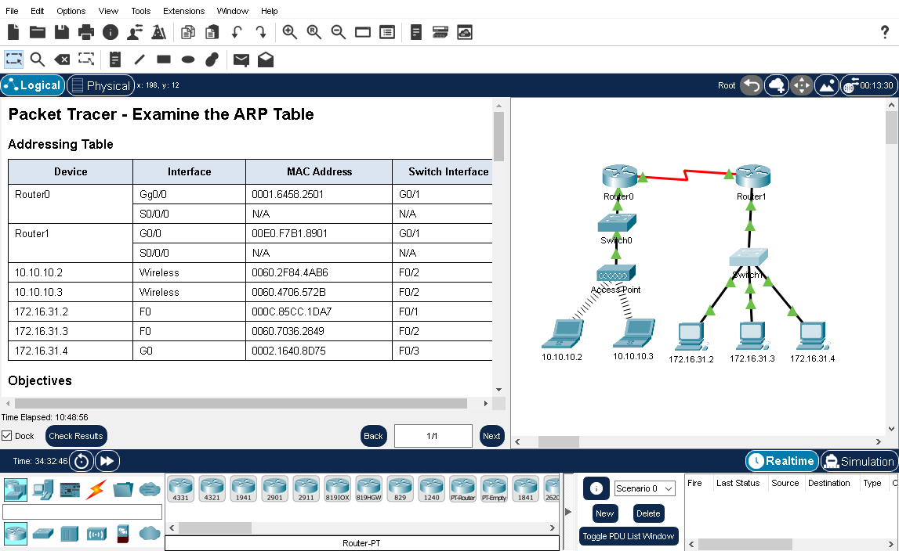

Addressing table is as follows:

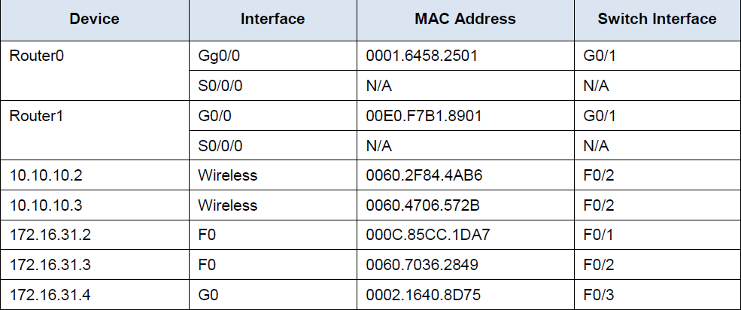

**Part 1: Examine an ARP Request**

**Step 1**: Generate ARP requests by pinging 172.16.31.3 from 172.16.31.2.

Open a command prompt

a. Click **172.16.31.2** and open the **Command Prompt**.

b. Enter the **arp -d** command to clear the ARP table.

Close a command prompt

c. Enter **Simulation mode** and enter the command **ping 172.16.31.3**. Two PDUs will be generated. The ping command cannot complete the ICMP packet without knowing the MAC address of the destination. So, the computer sends an ARP broadcast frame to find the MAC address of the destination.

d. Click **Capture/Forward** once. The ARP PDU moves **Switch1** while the ICMP PDU disappears, waiting for the ARP reply. Open the PDU and record the destination MAC address. Is this address listed in the table above?

Ans: no this is not in above table as it is not mac address of any device. It is a broadcast address.

e. Click **Capture/Forward** to move the PDU to the next device. How many copies of the PDU did **Switch1** make?

Ans: Three

What is the IP address of the device that accepted the PDU?

Ans: 172.16.31.3

f. Open the PDU and examine Layer 2. What happened to the source and destination MAC addresses?

Ans: Source became destination, FFFF.FFFF.FFFF turned into MAC address of 172.16.31.3

g. Click **Capture/Forward** until the PDU returns to **172.16.31.2**. How many copies of the PDU did the switch make during the ARP reply?

Ans: One

**Step 2:** Examine the ARP table.

a. Note that the ICMP packet reappears. Open the PDU and examine the MAC addresses. Do the MAC addresses of the source and destination align with their IP addresses?

Ans: Yes they are matching.

b. Switch back to Realtime and the ping completes.

c. Click **172.16.31.2** and enter the **arp –a** command. To what IP address does the MAC address entry correspond?

Ans: It corresponds to destination ip address which is **172.16.31.3**

In general, when does an end device issue an ARP request?

Ans: When it does not know the receiver’s MAC address.

**Part 2: Examine a Switch MAC Address Table**

**Step 1:** Generate additional traffic to populate the switch MAC address table.

a. From **172.16.31.2**, enter the ping **172.16.31.4** command.

b. Click **10.10.10.2** and open the **Command Prompt**.

c. Enter the **ping 10.10.10.3** command. How many replies were sent and received?

Ans: four were send and four received.

**Step 2:** Examine the MAC address table on the switches.

a. Click **Switch1**and then the **CLI** tab. Enter the **show mac-address-table** command. Do the entries correspond to those in the table above?

Ans: Yes

b. Click **Switch0**, then the **CLI** tab. Enter the show **mac-address-table** command. Do the entries correspond to those in the table above?

Ans: Yes

Why are two MAC addresses associated with one port?

Ans: The two laptops are connected to switch 0 using access point that’s why there are two mac addresses.

**Part 3: Examine the ARP Process in Remote Communications**

**Step 1:** Generate traffic to produce ARP traffic.

a. Click **172.16.31.2** and open the **Command Prompt**.

b. Enter the ping **10.10.10.1** command.

c. Type **arp –a**. What is the IP address of the new ARP table entry?

Ans: 172.16.31.1

d. Enter **arp -d** to clear the ARP table and switch to **Simulation mode**.

e. Repeat the **ping to 10.10.10.1**. How many PDUs appear?

Ans: Two PDUs appeared.

f. Click **Capture/Forward**. Click the PDU that is now at **Switch1**. What is the target destination IP destination address of the ARP request?

Ans: 172.16.31.1

g. The destination IP address is not 10.10.10.1. Why?

___________________________________________________________________________

**Step 2:** Examine the ARP table on Router1.

a. Switch to **Realtime mode**. Click **Router1** and then the **CLI** tab.

b. Enter privileged EXEC mode and then the **show mac-address-table** command. How many MAC addresses are in the table? Why?

___________________________________________________________________________

c. Enter the **show arp** command. Is there an entry for **172.16.31.2**?

___________________________________________________________________________

What happens to the first ping in a situation where the router responds to the ARP request?

___________________________________________________________________________